Liquid-liquid extraction
The separation of a component from a liquid mixture by treatment with a solvent in which the desired component is preferentially soluble is known as liquid-liquid extraction. The specific requirement is that a high percentage extraction of product must be obtained but concentrated in a smaller volume of solvent.
Prior to starting a large-scale extraction, it is important to find out on a small scale the solubility characteristics of the product using a wide range of solvents. A simple rule to remember is that 'like dissolves like'. The important 'likeness' as far as solubility relations are concerned is in the polarities of molecules. Polar liquids mix with each other and dissolve salts and other polar solids. The solvents for non-polar compounds are liquids of low or nil polarity.
The dielectric constant is a measure of the degree of molar polarization of a compound. If this value is known it is then possible to predict whether a compound will be polar or non-polar, with a high value indicating a highly polar compound. The dielectric constant D of a substance can be measured by determining the electrostatic capacity C of a condenser containing the substance between the plates. If C₀ is the value for the same condenser when completely evacuated then
D =C/C₀
Experimentally, dielectric constants are obtained by comparing the capacity of the condenser when filled with a given liquid with the capacity of the same condenser containing a standard liquid whose dielectric constant is known very accurately. If D₁ and D₂ are the dielectric constants of the experimental and the standard liquids and C₁ and C₂ are the electrostatic capacities of a condenser when filled with each of the liquids then
D₁/D2 = C₁/C₂
The value of D₁ can be calculated since C₁ and C₂ can be measured and D₂ is known. The final choice of solvent will be influenced by the distribution or partition coefficient K where
K= Concentration of solute in extract / concentration of solute in raffinate
The value of K defines the ease of extraction. when there is a relatively high K value, good stability of product and good separation of the aqueous and solvent phases, then it may be possible to use a Smgle-stilge extraction system (Fig. 10.24)
unfortunately, in a number of systems the value of K is low and co-current or counter-current multistage systems have to be utilized. The co-current system is illustrated in Fig. 10.25. There are n mixer/separator vessels in line and the raffinate goes from vessel 1 to vessel n. Fresh solvent is added to each stage, the feed and extracting solvent pass through the cascade in the same direction. Extract is recovered from each stage. Although a relatively large amount of solvent is used, a high degree of extraction is achieved
A counter-current system is illustrated in Fig. 10.26. There. are a number of mixer/separators connected in series. The extracted raffinate passes from vessel 1 to vessel n while the product-enriched solvent is flowing from vessel n to vessel 1. The feed and extracting solvent pass through the cascade in opposite directions. The most efficient system for solvent utilization is counter-current operation, showing a considerable advantage over batch and co-current systems. Unless there are special reasons the counter-current system should be used. In practice, the series of counter-current extractions are conducted in a single continuous extractor using centrifugal forces to separate the two liquid phases. The two liquid streams are forced to flow counter-current to each other through a long spiral of channels within the rotor

The Podbielniak centrifugal extractor (Fig. 10.27) consists of a horizontal cylindrical drum revolving at up to 5000 rpm about a shaft passing through its axis. The liquids to be run counter-current are introduced into the shaft, with the heavy liquid entering the drum at the shaft while the light liquid is led by an internal route to the periphery of the drum. As the drum rotates, the heavy liquid is forced to the periphery of the drum by centrifugal action where it contacts the light liquid. The solute is transferred between the liquids and the light liquid is displaced back towards the axis of the drum. The heavy liquid is returned to the drum's axis via internal channels. The two liquid streams are then discharged via the shaft. Flow rates in excess of 100,000 dm3 h- t are possible in the largest models. Probably the most useful property of this type of extractor is the low hold-up volume of liquid in the machine compared with the throughput.
Penicillin G is an antibiotic which is recovered from fermentation broths by centrifugal counter-current solvent extraction. At neutral pHs in water penicillin is ionized:
In acid conditions this ionization is suppressed and the penicillin is more soluble in organic solvents. At pH 2 to 3 the distribution ratio of total acid will be
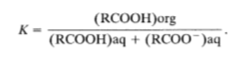

For penicillin this value may be as high as 40 in a suitable solvent. The penicillin extraction process may involve the four following stages:
- Extraction of the penicillin G from the filtered broth into an organic solvent (amyl or butyl acetate or methyl iso-butyl ketone).
- Extraction from the organic solvent into an aqueous buffer.
- Extraction from aqueous buffer into organic solvent.
- Extraction of the solvent to obtain the penicillin salt.
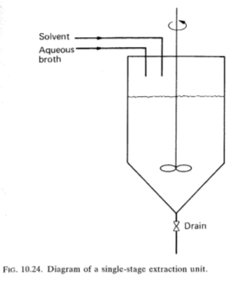

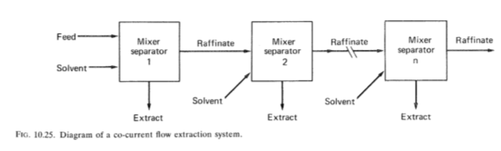

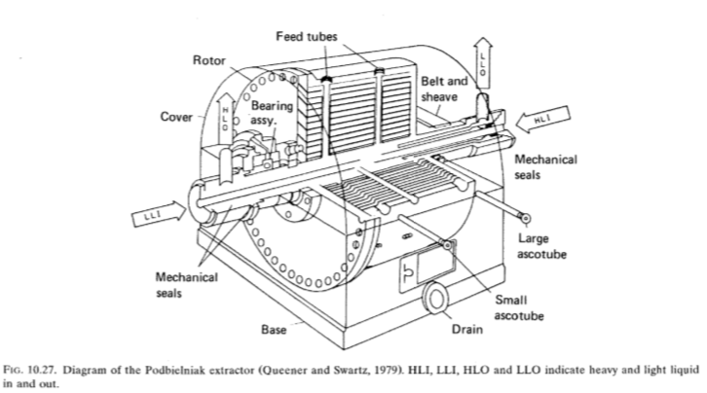

Reference
- Stanbury, The Recovery and Purification of Fermentation Products, Principles of Fermentation Technology, Second Edition.

